THE RISKS TO AUSTRALIA OF A 3°C WARMER WORLD.
Australian Academy of Science, March 2021.

This publication fails to follow the traditional ‘Scientific Method’.
It belittles the reputation of the Academy.
It fails to test the main basic hypotheses associated with ‘climate change’.
It builds on the current popular dogma of ‘climate change’ in a style more related to alarmist advocacy than to good, hard science.
An aside.
Dr Richard Feynman was a physicist whose popular public remarks about science and engineering are quoted here for their relevance and clarity. For the purpose of this criticism of the AAS publication, they are meant to be suggestive, rather than definitive, including this first quote from Feynman:
“In general, we look for a new law by the following process: First we guess it; then we compute the consequences of the guess to see what would be implied if this law that we guessed is right; then we compare the result of the computation to nature, with experiment or experience, compare it directly with observation, to see if it works. If it disagrees with experiment, it is wrong. In that simple statement is the key to science. It does not make any difference how beautiful your guess is, it does not make any difference how smart you are, who made the guess, or what his name is — if it disagrees with experiment, it is wrong.” Feynman.
https://www.azquotes.com/author/4774-Richard_P_Feynman

The ‘Hypothesis’ and the ‘Scientific Method’.

Here is one summary of the traditional scientific method: ‘Hypothesis-based deduction. The central concept of the traditional scientific method is a falsifiable hypothesis regarding some phenomenon of interest. This hypothesis is to be tested experimentally or computationally. The test results support or refute the hypothesis, triggering a new round of hypothesis formulation and testing.
https://doi.org/10.1371/journal.pcbi.1007279.g001

The basic hypotheses of ‘climate change’ are not clearly stated in this AAS publication. They are assumed, as indicated at page 8
“There is no scientific doubt about the source, reality and consequences associated with the current level of unmitigated climate change. human activities, such as the burning of fossil fuels and the destruction of forests, are rapidly changing earth’s climate.”
These assertions are factually incorrect, because many scientists have stated doubts about reality, for example Dr Judith Curry -
“Climate change has thus become a grand narrative in which human-caused climate change has become a dominant cause of societal problems. Everything that goes wrong then reinforces the conviction that that there is only one thing we can do prevent societal problems – stop burning fossil fuels. This grand narrative misleads us to think that if we solve the problem of manmade climate change, then these other problems would also be solved. This belief leads us away from a deeper investigation of the true causes of these problems. The end result is narrowing of the viewpoints and policy options that we are willing to consider in dealing with complex issues such as public health, weather disasters and national security. And so, climate becomes everything.”
https://judithcurry.com/2021/05/02/climate-is-everything/
The following are proposed as representing the main thrust of the hypotheses on which the AAS authors rely.

- Anthropogenic greenhouse gas emissions are the main source of increased atmospheric carbon dioxide concentrations in the atmosphere.
- Anthropogenic carbon dioxide concentrations in the atmosphere are among the main causes of global warming. (Page 26 “Representative concentration pathways, or RCPs, are scenarios that show how different levels of greenhouse gas emissions and aerosol concentrations, as well as land use, lead to different global warming trajectories and associated impacts over time.”)
- Reduction of fossil fuel combustion can affect climate change. (Page 11, “Reaching net zero emissions by mid-century is an absolute minimum if we are to avoid the worst impacts of climate change.”)

Some statement of fundamental hypotheses is not unusual for a review publication of this type. This allows deduction of whether a hypothesis is falsified or not by the evidence offered by the authors.

If these hypotheses as expressed are accepted by the AAS authors as adequate, they fail as shown by several examples of past observation and measurement able to falsify these hypotheses. While these examples are available by literature search, they are not referenced in this AAS report, which shows bias.

Some general criticisms.
The AAS publication has more than 450 references and a statement that the publication was reviewed by 6 named individuals. Three of the reviewers have authored or co-authored about 18 of the papers listed in the references. There is scientific etiquette that a reviewer does not review his/her own prior publications, yet here we see senior scientists from the climate change sector doing just that.
Some of the reviewers are eminent in fields other than climate studies, yet still chosen as reviewers. This should reduce any tendency to dismiss my geochemist experience on the grounds that I am not a climate researcher.
The AAS authors appear to ‘cherry pick’ when considering methods for future energy generation. Recommendation 7 of the AAS publications mentions “… the rapid phase-out of fossil fuels by mid-century” but no recommendation mentions a non-intermittent replacement. Some scientists consider that future removal of fossil fuel from national energy generation has to be balanced by a non-intermittent alternative. Nuclear is often mentioned. Generation by wind and solar needs non-intermittent back-up generation, with nuclear and fossil fuels being the main logical candidates. This has been known for decades. A word search of the AAS publication for ‘nuclear’ and found no matches.
In traditional hard science, uncertainty estimates of measurements are made very often, as a guide to the credibility and signal:noise ratio of numbers. This publication seems to discard numerical uncertainty as a concept, by not mentioning it.
“It is in the admission of ignorance and the admission of uncertainty that there is a hope for the continuous motion of human beings in some direction that doesn't get confined, permanently blocked, as it has so many times before in various periods in the history of man. If you thought that science was certain - well, that is just an error on your part”. Feynman.

Some remarks about the authority of some of the AAS authors.
Word searches for ‘debated’ (1), ‘questionable’ (0). ‘debatable’ (0), ‘contestable’ (0), ‘mistake’ (0), ‘error’ (0), ‘wrong’ (0), ‘redacted’ (0), though not quantitative guides to the quality of a publication, provide some indirect indication of the confidence of the author(s) that their work and references are correct.
Scientific integrity can arise when authors quote retracted papers without mention of the retraction, or papers involved in unmentioned public controversy about replication. As Pielke and Ritchie note recently. ‘Today, many areas of science face challenges related to research integrity. For instance, the so- called “replication crisis” has focused on the irreproducibility of published studies. Stagge et al. (2019) find that less than 7% of articles published in six hydrology and water resources journals in 2017 are reproducible.’
http://dx.doi.org/10.2139/ssrn.3581777
This AAS publication cites Jacobson 2017 without reference to calls for its retraction such as by Clack 2017 and related law suits.
https://www.pnas.org/content/114/26/6722
There is also no mention of decision of the editor of Journal of Climate, John Chiang, to rescind acceptance of a climate paper whose authors include AAS author Karoly, on 9th June 2012.
The publication does not advise readers that some authors including Karoly, Church and Pearman made public statements around 2016 after two were asked to leave CSIRO employment.
Author Hoegh-Guldberg is a Director of the Centre for Excellence in Coral Reef Studies. That Centre is associated with Philip Munday and Danielle Dixson, authors of a paper being investigated for alleged lack of replication by a group headed by T. Clark 2020 as published in Nature.
https://www.nature.com/articles/s41586-019-1903-y
That centre is also involved in litigation over claims by former Professor Peter Ridd, due for hearing in the High Court of Australia in June 2021.
There was a year 2020 public disagreement between author Steffen and critic Franzen. Steffen co-authored a 2018 article about fact checking containing ‘It is true that the article by Steffen and co-workers is “intended to highlight [...] the high side of the risk distribution”.’ This is an admission by an author that advocacy was used, which is one of the criticisms of this AAS publication.
http://iflas.blogspot.com/2020/02/fact-checking-climate-crisis-franzen-vs.html

“Looking back at the worst times, it always seems that they were times in which there were people who believed with absolute faith and absolute dogmatism in something. And they were so serious in this matter that they insisted that the rest of the world agree with them. And then they would do things that were directly inconsistent with their own beliefs in order to maintain that what they said was true”. Feynman.

Given that there is only one Earth, traditional techniques like replication, validation, dealing with uncertainty and so on are difficult and sometimes impossible. However, as time passes, earlier publications that made forecasts or projections can be tested against measured and observed data since their publication.
One such evaluation deals with the origins of government legislation in the USA to combat global warming. It is about testimony to the US Senate by Dr James Hansen in June 1988, tested against the actuality of the following 30 or so years. (This reference is offered to invite rebuttal of its content, not to invite criticism of its blog source).
https://wattsupwiththat.com/2021/04/22/history-confirms-democrats-1988-senate-global-warming-hearing-got-everything-wrong-from-start-to-finish/
If this analysis stands, then it is clear that the movement, now generically ‘climate change’, started off on the wrong foot by Hansen, has worsened and gained greater government involvement.
“No government has the right to decide on the truth of scientific principles, nor to prescribe in any way the character of the questions investigated. Neither may a government determine the aesthetic value of artistic creations, nor limit the forms of literacy or artistic expression. Nor should it pronounce on the validity of economic, historic, religious, or philosophical doctrines. Instead, it has a duty to its citizens to maintain the freedom, to let those citizens contribute to the further adventure and the development of the human race.” Feynman.

Some specific criticisms.
Climate sensitivity.
Extract from Page 7. ‘The total emission reductions currently pledged by the Australian and international governments through the United Nations Framework Convention on Climate Change Paris Agreement (UNFCCC), even if implemented on time, will translate as average global surface temperatures of 3°C or more above the pre-industrial period by 2100.’
Criticism: There is no established, quantitative link between emissions and global surface temperatures, generally termed ‘climate sensitivity’, so no estimate of a 3°C change is possible. The last relevant official IPCC statement was a footnote in IPCC, 2013: Summary for Policymakers. In: Climate Change 2013: The Physical Science Basis. SPM page 16. It reads ‘No best estimate for equilibrium climate sensitivity can now be given because of a lack of agreement on values across assessed lines of evidence and studies.’ The image below is one summary of how estimates of ECS and TCR have varied over the years. It cannot be assumed that future reductions in emissions (in the usual sense) will cause lower surface temperatures, because it has not been shown that past variations in emissions are able to be linked to past variations in temperature in ways that allow prediction.
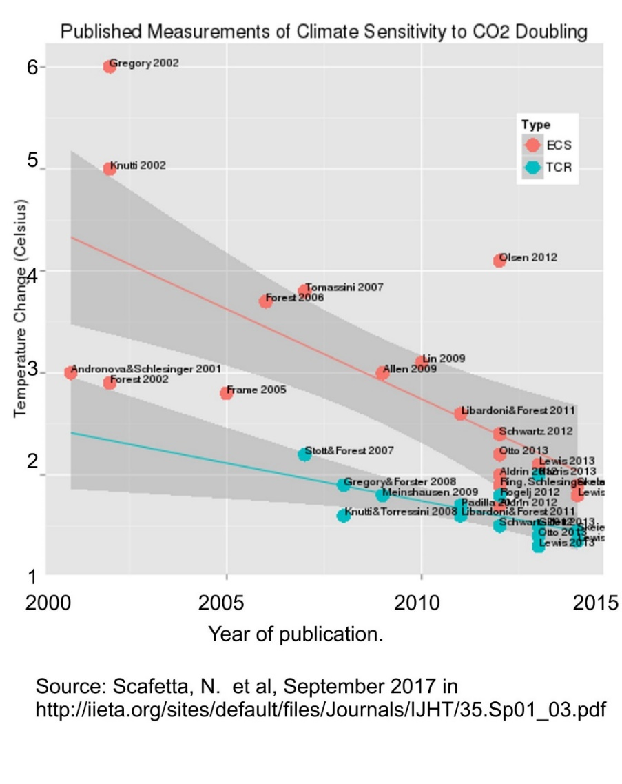
Also, most recent reconstructions of historic global surface temperatures have a rise from about 1910 to 1945 that is similar to a rise from 1975 to 2005. (see graph following, from NOAA but modified here by the addition of coloured lines showing broad trend patterns). There is a fall from 1945 to 1975. There is a large, unsettled lack of explanation for the first rise, which was before 1950 when greenhouse gas emissions rose more sharply.
There is an obvious need to separate climate effects caused by mankind from those that are natural, but there has been little or no success with such differentiation, apart from uncertain modelling like attribution studies.
It is not possible to allocate the 1980 to 2020 rise exclusively or in any known portion to the actions of mankind as the AAS publication seems to attempt.
- Hypothesis 1 is falsified. (That anthropogenic greenhouse gas emissions are the main source of increased atmospheric carbon dioxide concentrations in the atmosphere).

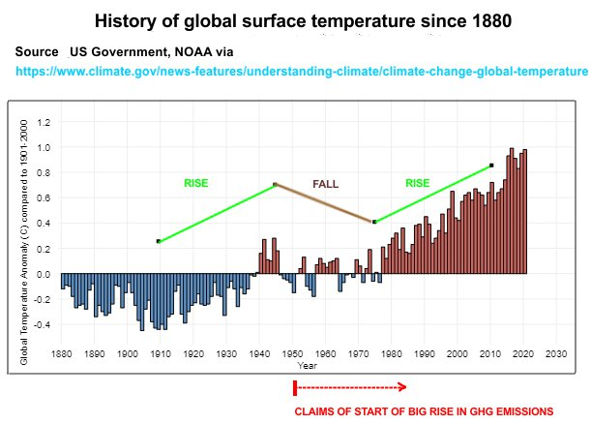

After the date of this AAS publication, there was a reduction of emissions caused by Covid-19 responses, estimated to be at least 8% globally. The effect of this was undetected in routine measurement of CO2 in air at the usual locations such as Mauna Loa and Cape Grim. In practical terms, these AAS authors call for a gross reduction in future CO2 emissions, but it is possible that they in turn will have no measurable effect. How are producers to be rewarded or punished for future emissions if the effect of an 8% reduction for a year is not detected?
One possible explanation for the lack of CO2 change from the lockdowns is that most of the variation in atmospheric CO2 is from long term natural sinks and sources, which are much larger in magnitude than man-made emissions, though a variety of mechanisms has been proposed. Here is one.
https://assets.researchsquare.com/files/rs-57102/v1_stamped.pdf
Hypothesis 2 is falsified. (That anthropogenic carbon dioxide concentrations in the atmosphere are among the main causes of global warming).

Australian land temperature change.
Extract from Page 7. ‘The planet is well on the path to devastating climate change. In 2019, Australia’s warmest year on record, average surface temperatures were 1.1°c above the pre-industrial period.”
Criticism: Whole continents like Antarctica and Africa have inadequate temperature measurements, particularly for the period before 1870 to 1950. More than half of the global ocean area was essentially unmeasured before 1950. Since adequate measurements began, Antarctica has had essentially no temperature change as indicated by thermometry, and no substantial decadal reduction in ice extent - hence presumably no ‘devastating’ climate change. Further, there is unsettled debate about factors affecting measured land temperatures, such as the urban heat island effect, variability caused by clouds, interactions with local rainfall, metrication and rounding errors and subjective adjustments like homogenisation. For Australia, add continuing addition of hotter sites to the ACORN-SAT group of stations and the adoption of different designs of instruments and housings.
Nobody can put an accurate figure on global temperature change since 1870 because the required data do not exist and never have.
For Australia, the main adjusted temperature set curated by the BOM (‘ACORN-SAT’) has deficiencies that make it invalid for some applications. It is not capable of demonstrating the alleged warming rate of about 1⁰C per century. The differences between raw data, various versions of ACORN-SAT (now 3 versions), AWAP, gridded sets and the earlier High Quality temperature sets can be enclosed by bounds of uncertainty that approach this alleged change. The signal:noise ratio is poor.
Some complexities in comparing raw temperatures with ACORN-SAT are shown here:
http://www.waclimate.net/very-hot-days.html

Heat wave frequency, severity and duration.
Extract from page 10. ‘Close to 90% of Australians live in cities and towns and will experience climate change impacts from the perspective of an urban environment. The risks of extreme events such as heatwaves … continue to increase and will be more intense and frequent as temperatures exceed 2°c of warming’.
Criticism. The simple expression of heat waves in a city can be calculated from the highest temperature averaged over a chosen number of consecutive days in a year and displayed in a plot of this temperature against year. Here are the results of such analysis for the hottest 40 of 5-day and 10-day heat waves in Melbourne since 1856. This pattern does not invite alarm.

Such graphs for the Australian capitals Brisbane, Sydney, Melbourne, Hobart, Adelaide and Perth, with data to the end of year 2019 are referenced below. They show heat waves from both BOM raw data and the BOM ACORN-SAT adjusted data sets. The ‘Top 40’ hottest events from the whole annual history are ranked and graphed. There are also graphs showing the number of days each year when a maximum daily temperature exceeded the old Century mark of 100⁰F or 37.8⁰C.
http://www.geoffstuff.com/heatwave_capitals.xlsx
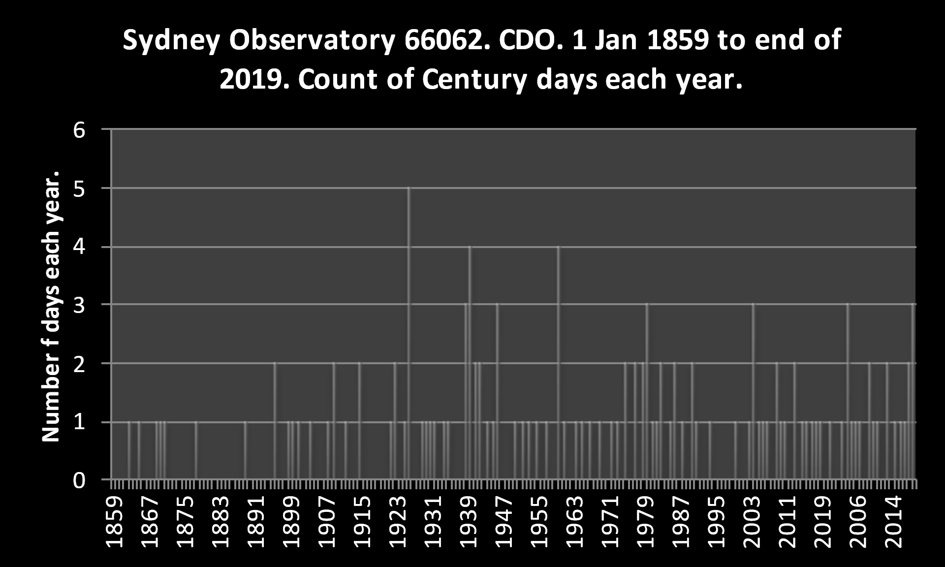
The above AAS assertion that risks of extreme events such as ‘heatwaves … continue to increase and will be more intense and frequent as temperatures exceed 2°c of warming’ is disputed. For example, most of the hottest heatwaves in the east coast capitals are in Melbourne, some 500 km further from the Equator than Sydney and 1,000 km further from the Equator than Brisbane. Roughly, average maximum temperatures are Melbourne 20⁰C, Sydney 23⁰C and Brisbane 25⁰C a trend expected from latitude. The average temperature reached in the hottest 40 past 5-day heat waves is Melbourne, 39⁰C, Sydney 33⁰C, Brisbane 33⁰C, the reverse of latitude effects.
Heat waves can involve the relocation of masses of hot air from where they are normally located, to distant cooler places where they are not normally located and labelled as heat waves. If this is so, it follows that there is limited value in linking heatwave studies to the ambient conditions of sites where they happen. By this reasoning, the frequency of heatwaves is then more related to the frequency of meteorological events that shift these air masses but there is little literature to address this.
High temperatures can be limited as happens over tropical parts of oceans. A theorised 2 degrees of global warming might have little or no detectable effect on the highest temperatures reached in future heat waves.
Higher ambient temperature need not lead to a more intense heat waves.

Oceanic heat waves.
Extract from page 31. ‘Periods of extreme heat (known as heatwaves) are increasing in length, frequency and intensity on land and in coastal and oceanic waters …’
Criticism: The Argo float exercise has produced results to help understand many ocean temperature measurements and their circumstances. Some temperature results follow as a graph. It shows the comparative rarity of observations above about 30⁰C. (There might be a negative feedback using cloud cover to prevent systematically higher temperatures). Questions include: How can there be oceanic heat waves when the SST seldom rises above 30⁰C? Per authors like Oliver et al below, one answer is that a heat wave can happen in cold water (below 20⁰C) through a climatology excursion of 2-3⁰C. How many people would call this a heat wave? How is it distinguished from a sea-bottom megaplume? Has sea floor volcanic activity been eliminated as a cause? Has any cause been postulated?
https://www.nature.com/articles/ncomms16101?origin=ppub
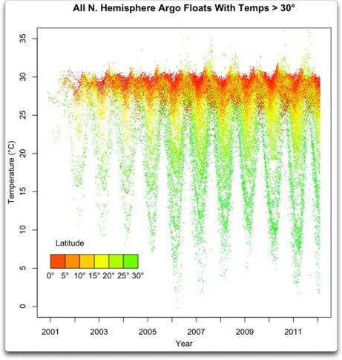
Graph source, Eschenbach, W. 2012. https://wattsupwiththat.com/2012/02/12/argo-and-the-ocean-temperature-maximum
Eschenbach contributed a related graph that shows little evidence of surface ocean warming over the last 4 decades. It needs to be considered when claims are made to the effect that warmer ocean temperatures are leading to lower annual Antarctic ice extents, in conjunction with data on deeper water temperatures and their dynamics.
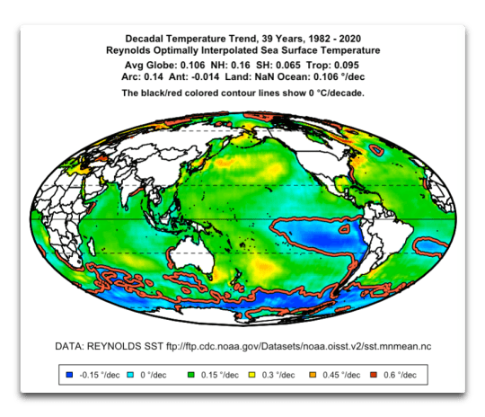
https://wattsupwiththat.com/2021/04/23/how-global-warming-isnt/

Sea level change.
Extract from page 10. ‘Close to 90% of Australians live in cities and towns and will experience climate change impacts from the perspective of an urban environment. The risks of extreme events such as coastal inundation from sea level rise … continue to increase and will be more intense and frequent as temperatures exceed 2°c of warming’.
Criticism. From the NOAA graph below, the tide gauge at Fort Denison in Sydney Harbour provides these annual measurements of level change from about 1885 to 2015, to which is added an imaginary projection of another 24 cm rise by the 2050s (a number from figure 5 of the AAS publication). The projected ‘coastal inundation from sea level rise’ is possible, but simply unlikely based on this long observation. Also, the Sydney data show no change in thermosteric expansion attributable to an alleged impact of levels of atmospheric CO2 and a warmer atmosphere. If greenhouses gases caused measurable abnormal warming from 1970 onwards (Church et al 2013b in the AAS publication), the graph fit below would not be a straight line. It is possible that there is a change that is offset by another effect (for example, SO2 changes in the air) acting oppositely, but there does not seem adequate evidence from measurement and observations to date to quantitatively demonstrate such an offset.
Ocean levels being what they are, the Sydney observations after GPS correction cannot differ significantly over the long term from other parts of the Australian coastline and are thus representative of Australia as a whole for the purposes of this analysis. The detrended Sydney data show a change from 0.65 ± 0.10 mm per year that becomes +0.739 ± 0.101 mm per year after GPS correction for movement of the land with respect to a reference. Extreme sea level changes are not to be expected, depending one subjective definitions of ‘extreme’.
Source: https://sealevel.info/MSL_graph.php?id=680-140
GPS corrections: https://www.degruyter.com/document/doi/10.1515/nleng-2020-0007/html
To the extent that oceans act as thermometers by expansion of their waters, there is a lack of discussion about why the temperature patterns from tide gauges do not resemble the temperature patterns from thermometers.

Net zero emissions.
Extract from page 12. ‘Acting early to transition to net zero emissions would reduce the scale of climate change impacts and have significant potential benefits for human health and regional development, as well as creating new industrial opportunities.’
Criticism: This statement is assertion devoid of evidence in its favour. For example, this scenario has run for some years in Germany with its Energiewende, a national plan to minimise nuclear and fossil fuel use for electricity generation, in favour of intermittent sources. Germany and other counties have measurements to show that final, all-up electricity costs rise in rough proportion to the loss of fossil and nuclear fuelled generation. Germany saw no measurable reduction of its emissions over the last decade, but had a steep rise in costs and a policy reversal, now in progress, to restart some of its shuttered brown coal plants.
https://spectrum.ieee.org/energy/renewables/germanys-energiewende-20-years-later

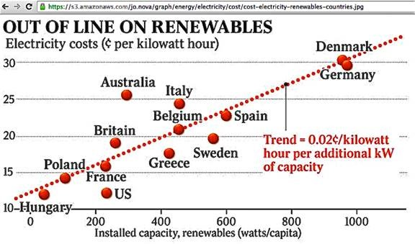
Further, most synthetic nitrogenous fertilizers are made from natural gas. If that gas use is reduced or stopped, global food production would fall and this would plausibly cause a detrimental health outcome, not the claimed beneficial outcome. This AAS publication would be helped by quantitative economic studies inclusive of such effects.

Models.
Extract from page 36. ‘understanding how earth’s climate system will change as global warming reaches 3°c or more above the pre-industrial period is challenging but essential given our current trajectory and poor understanding of sudden changes, synergies, and other non-linear responses (Christoff 2014). some insights, however, can be drawn from trends established over the last 50–100 years, mechanistic understandings from observations, global circulation models (IPCC 2013b) and other types of mathematical models (Braganza et al. 2014; Hoegh-Guldberg et al. 2018; Whetton et al. 2014).’
Criticism: In the absence of a duplicate Earth for experiments, resort has to be made to modelling to construct hypotheses about the future. There are many earth models whose results are compared in Coupled Model Intercomparison Projects (CMIP6 is the most recent.)
https://www.carbonbrief.org/cmip6-the-next-generation-of-climate-models-explained
For such modelling to be more easily compared, the IPCC produced scenarios fixing the range of major parameters to be expected in the future. These include the concept of Representative Concentration Pathway, RCP, with the most extreme being RCP8.5.
On a global modelling scale, future global surface temperature models do not track at all closely with observations (Two graphs follow. Sea temperatures are from 2021 data, all globe from 2018 data).
At page 29 of the AAS publication, there is a footnote to Figure 5, “Note that Australian mean temperature is 1.4 times higher than the global average, which explains the slight differences to figure 1. (figure provided by Michael Grose; modified from CSIRO & BoM 2020)”. This is not ‘slight’. It is too major a discrepancy for a note referencing an unexplained personal communication. It is at the very heart of comparing Australian model performance and global.
This AAS publication has many instances like this where inconvenient data are submerged, when they should be a major part of such a review of science known to the sector at the time.
You must do the best you can—if you know anything at all wrong, or possibly wrong—to explain it. If you make a theory, for example, and advertise it, or put it out, then you must also put down all the facts that disagree with it, as well as those that agree with it. There is also a more subtle problem. When you have put a lot of ideas together to make an elaborate theory, you want to make sure, when explaining what it fits, that those things it fits are not just the things that gave you the idea for the theory; but that the finished theory makes something else come out right, in addition. Feynman.
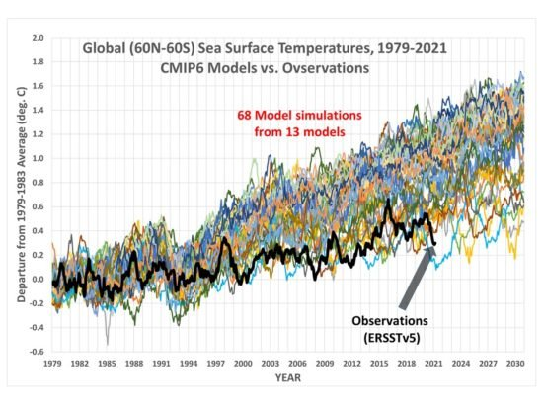http://www.drroyspencer.com/2021/04/an-earth-day-reminder-global-warming-is-only-50-of-what-models-predict/
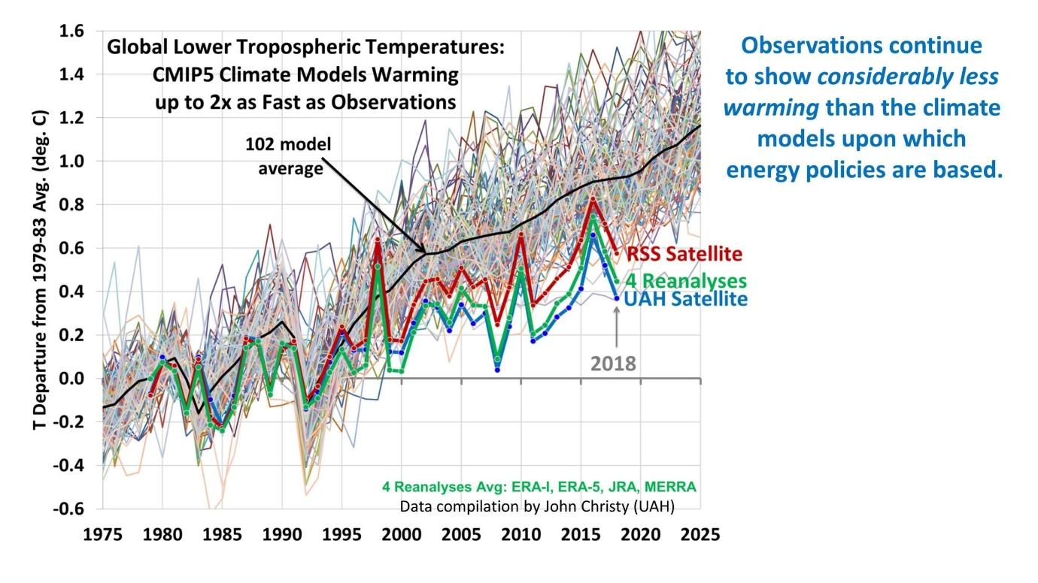
https://www.drroyspencer.com/wp-content/uploads/ICCC13-DC-Spencer-25-July-2019-Global-LT-scaled.jpg

In Conclusion.
Almost every one of the 75 or so pages in the body of this AAS publication has assertions that are eminently contestable. Essentially, few are contested in the publication.
Science advances by the resolution of differences. It proceeds less well by ignoring differences, or relegating them to footnotes.
The few examples given above contest material in the AAS publication. They are not selected for any particular property other than to show that other scientists have differences about significance and rigour. These are not the biggest or most newsworthy, or the most fundamental differences. They can be questioned, as they have been elsewhere as, for example, blog comments show in the links provided.
However, it remains that the certainty suggested by the authors of this AAS publication does not exist. There is much reliance on the results of modelling, now using supercomputers. Access to supercomputers is not really available to those with dissenting views, but maybe it is not needed. The IPCC has expressed limits to the ability of modelling. Modelling does not produce data.
The climate system is a coupled non-linear chaotic system, and therefore the long-term prediction of future climate states is not possible.
https://www.ipcc.ch/site/assets/uploads/2018/03/TAR-14.pdf
The three hypotheses constructed for this AAS publication have been falsified by the examples in this essay.
(End)

