“There will always be doubt. There is no doubt about that.”

Some puzzles stay unsolved.

On the topic of noise in the BOM-style thermometry, some people start with an assumption that you can improve measurements successively until you get the same answer all of the time. Having owned an analytical chemistry laboratory, my approach is that there is an element of irreducible error inherent in every measurement process. In the end, it all depends on what the customer finds acceptable.

Long ago, others wrote of the differences between symmetric noise that cancels to zero after a number of observations of the same type; and “bias noise” that leaves you with a nasty residual that typically requires more effort to minimise. You can do an exercise where you take a large number of successive observations where you try to keep the *ceteris paribus* as low as possible then calculate the standard deviation, a process that assumes you have symmetric noise dominant. I have not done this rigidly and formally with BOM thermometry, preferring to ask BOM to do it. They have taken nearly 3 years of non-answers so far. Lacking formalism, I can only give a “feel” for the S.D. results, which places them at about 0.2⁰C for 1 S.D. Others will derive different figures. It follows for me that I would prefer not to attribute differences of less than 0.2⁰C to physical effects such as day of the week. But then, I have a bee in the bonnet about the lack of proper treatment of errors in climate work. Too many times they are ignored, like the metrication error and the error going from LIG to electronic sensors.

On a related topic, I was looking for the recent Ayers paper that mentions that the difference between visible graph noise between daytime and nighttime obs is due to atmospheric circulation of a partially-mixed air around the Stevenson or whatever screen. This, one would assume, is symmetric noise that can cancel to zero and so can be coped with. One level of error for the day, another for the night. But, what to do when you are taking obs at a fixed time each day like 1900 hours? Sun is there in summer, not there in winter, at some latitudes. Which error estimate do you use then?

I have rediscovered this old graph I made.

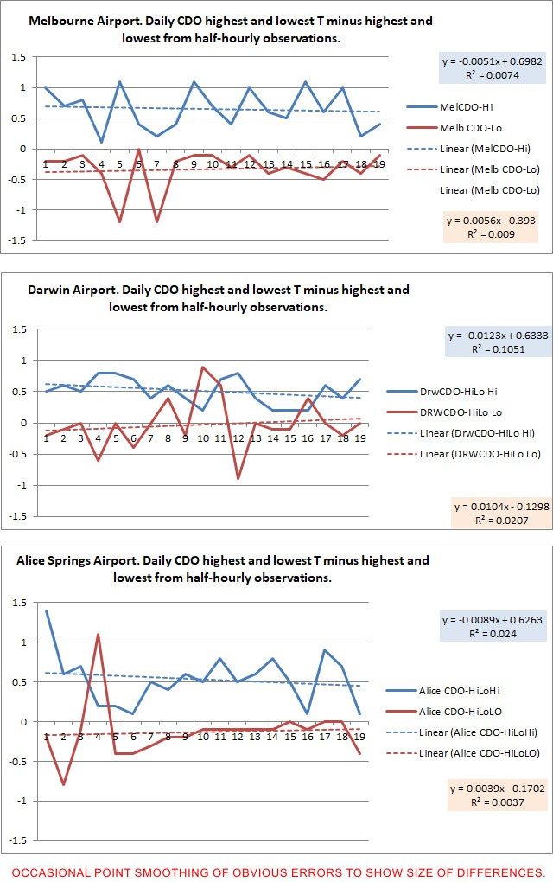

Temperatures for 20 consecutive days in March 2020 were calculated from CDO and from the half-hourly data set on the BOM (which I have labelled as HiLo).

There are obvious large and systematic differences.

These differences are far too large to pass uncorrected, given that they originate at each station from the same sensor in the same box. The big question is, with data processing procedure is the correct one? If you seek to compare LIG data in time with electronic, which data method do you use?

Here is the BOM response to the difference, in which they acknowledge differences but stick with an error because it best matches data from olden times:

**In reply please quote: K5Q9646525**  
  
Dear Geoff,  
  
The discrepancy you are finding is explained by the differences in the datasets you are using.  
  
Our automatic weather stations send in an observation message each minute which is generated from 60 one-second samples across the previous minute. For air-temperature, this will include an instantaneous (one-second) temperature reading, along with a maximum/minimum reported over the previous minute.  
  
The daily maximum/minimum (9am-9am data available on CDO) value is ​derived from the one-minute dataset.  
  
The half-hourly dataset reports an instantaneous (one-second) temperature reading on the half-hour or hour.  
  
In most cases, the maximum/minimum for the day (i.e. highest/lowest one-second temperature reading) will not be captured in the half-hourly dataset; that is, the maximum/minimum will not usually fall on the half-hour or hour.  
  
The results you are seeing is consistent with the reporting procedures above - the daily maxmimum/minimum will in most cases be higher/lower than the temperatures reported in the half-hourly data.  
  
In terms of mean daily temperature there are different ways to calculate this depending on requirements. For long term climate purposes, the mean of the daily maximum and minimum is used as it provides the longest consistent method. Generating a daily mean temperature across all available observations (e.g. using half-hourly or three-hourly data) may provide a more representative value, but does not provide as long period of record.

I do not buy their argument. I cannot see this degree of difference in the plots of data of various types that Ken has shown. They are more or less saying that the temperature in the hot part of the day usually gets half a degree hotter in the half-hour that hosts the final one second. I think.